# Land Use, Land-Use Change, and Forestry

## Land Converted to Wetlands (CRT Source Category 4D2)

**Land Converted to Flooded Land**

Flooded lands are defined as water bodies where human activities have 1) caused changes in the amount of surface area covered by water, typically through water level regulation (e.g., constructing a dam), 2) waterbodies where human activities have changed the hydrology of existing natural waterbodies thereby altering water residence times and/or sedimentation rates, in turn causing changes to the natural production of greenhouse gases, and 3) waterbodies that have been created by excavation, such as canals, ditches and ponds (IPCC 2019). Flooded lands include waterbodies with seasonally variable degrees of inundation but would be expected to retain some inundated area throughout the year under normal conditions.

Flooded lands are broadly classified as “reservoirs” or “other constructed waterbodies” (IPCC 2019). Reservoirs are defined as flooded land greater than 8 ha and includes the seasonally flooded land on the perimeter of permanently flooded land (i.e., inundation areas). IPCC guidance (IPCC 2019) provides default emission factors for reservoirs and several types of “other constructed waterbodies” including freshwater ponds and canals/ditches.

Land that has been flooded for 20 years or greater is defined as flooded land remaining flooded land and land flooded for less than 20 years is defined as land converted to flooded land. The distinction is based on literature reports that CO2 and CH4 emissions are high immediately following flooding as labile organic matter is rapidly degraded but decline to a steady background level approximately 20 years after flooding (Abril et al. 2005, Barros et al. 2011, Teodoru et al. 2012). Both CO2 and CH4 emissions are estimated for land converted to flooded land.

Nitrous oxide emissions from flooded lands are largely related to inputs of organic or inorganic nitrogen from the watershed. These inputs from runoff/leaching/deposition are largely driven by anthropogenic activities such as land-use change, wastewater disposal or fertilizer application in the watershed or application of fertilizer or feed in aquaculture. These emissions are not included here to avoid double-counting N2O emissions which are captured in other source categories, such as indirect N2O emissions from managed soils (Section 5.4, Agricultural Soil Management) and wastewater management (Section 7.2, Wastewater Treatment and Discharge).

Reservoirs are designed to store water for a wide range of purposes including hydropower, flood control, drinking water, and irrigation. The permanently wetted portion of reservoirs are typically surrounded by periodically inundated land referred to as a “drawdown zone” or “inundation area.” Greenhouse gas emissions from inundation areas are considered significant and similar per unit area to the emissions from the water surface and are therefore included in the total reservoir surface area when estimating greenhouse gas emissions from flooded land. Lakes converted into reservoirs without substantial changes in water surface area or water residence times are not considered to be managed flooded land (see Area Estimates below) (IPCC 2019).

In 2022, the United States and Puerto Rico contained 72,461 ha of reservoir surface area in land converted to flooded land (see Methodology and Time-Series Consistency below for calculation details) distributed across all six of the aggregated climate zones used to define flooded land emission factors (Figure 6‑17) (IPCC 2019).

**Emissions from Land Converted to Flooded Land–Reservoirs**

**Figure 6‑17: U.S. Reservoirs (black polygons) in the Land Converted to Flooded Land Category in 2022**

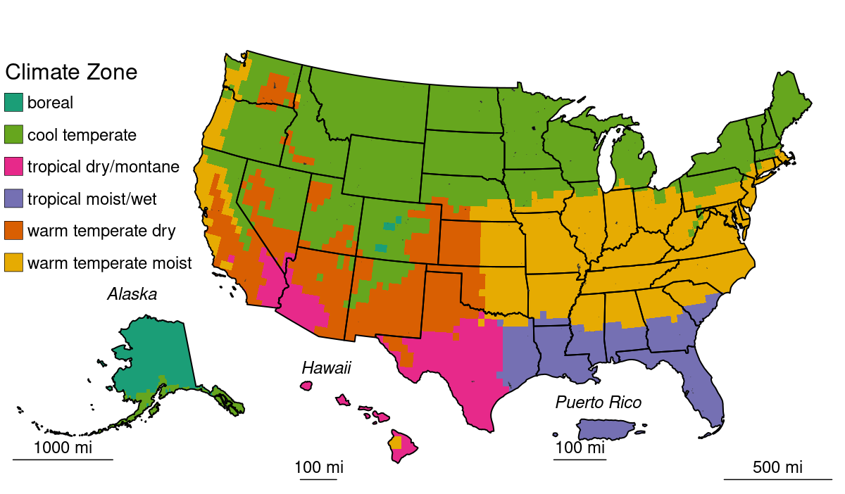

Note: Colors represent climate zone used to derive IPCC default emission factors. Reservoirs (indicated by black polygons) are sparsely distributed across United States, but can be seen in MN, IL, and IN in this image.

Methane and CO2 are produced in reservoirs through the natural breakdown of organic matter. Per unit area emission rates tend to scale positively with temperature and system productivity (i.e., abundance of algae). Greenhouse gases produced in reservoirs can be emitted directly from the water surface and inundation areas or as greenhouse gas-enriched water passes through the dam and the downstream river. Sufficient information exists to estimate downstream CH4 emissions using Tier 1 IPCC guidance (IPCC 2019), but no guidance is provided for downstream CO2 emissions. Table 6‑101 and Table 6‑102 below summarize nationally aggregated CH4 and CO2 emissions from reservoirs in land converted to flooded land. The decrease in CO2 and CH4 emissions through the time series is attributable to reservoirs matriculating from the land converted to flooded land category into the flooded land remaining flooded land category. Emissions have been stable since 2005, reflecting the low rate of new flooded land creation over the past 17 years.

**Table 6‑101: CH4 Emissions from Land Converted to Flooded Land—Reservoirs (MMT CO2 Eq.)**

|  |  |  |  |  |  |  |  |
| --- | --- | --- | --- | --- | --- | --- | --- |
| **Source** | **1990** | **2005** | **2018** | **2019** | **2020** | **2021** | **2022** |
| **Reservoirs** |  |  |  |  |  |  |  |
| Surface Emissions | 2.5 | 0.4 | 0.2 | 0.2 | 0.2 | 0.2 | 0.2 |
| Downstream Emissions | 0.2 | + | + | + | + | + | + |
| **Total** | **2.7** | **0.4** | **0.2** | **0.2** | **0.2** | **0.2** | **0.2** |
| +Indicates values less than 0.05 MMT CO2  Note: Totals may not sum due to independent rounding. | | | | | | | |

**Table 6‑102: CH4 Emissions from Land Converted to Flooded Land—Reservoirs (kt CH4)**

|  |  |  |  |  |  |  |  |
| --- | --- | --- | --- | --- | --- | --- | --- |
| **Source** | **1990** | **2005** | **2018** | **2019** | **2020** | **2021** | **2022** |
| **Reservoirs** |  |  |  |  |  |  |  |
| Surface Emissions | 90 | 14 | 7 | 7 | 7 | 7 | 7 |
| Downstream Emissions | 8 | 1 | 1 | 1 | 1 | 1 | 1 |
| **Total** | **98** | **15** | **8** | **8** | **8** | **7** | **7** |
| Note: Totals may not sum due to independent rounding. | | | | | | | |

**Table 6‑103: CO2 Emissions from Land Converted to Flooded Land—Reservoirs (MMT CO2)**

|  |  |  |  |  |  |  |  |
| --- | --- | --- | --- | --- | --- | --- | --- |
| **Source** | **1990** | **2005** | **2018** | **2019** | **2020** | **2021** | **2022** |
| Reservoir | 3.5 | 0.6 | 0.3 | 0.3 | 0.3 | 0.3 | 0.3 |

**Table 6‑104: CO2 Emissions from Land Converted to Flooded Land—Reservoirs (MMT C)**

|  |  |  |  |  |  |  |  |
| --- | --- | --- | --- | --- | --- | --- | --- |
| **Source** | **1990** | **2005** | **2018** | **2019** | **2020** | **2021** | **2022** |
| Reservoir | 0.9 | 0.2 | 0.1 | 0.1 | 0.1 | 0.1 | 0.1 |

Methane and CO2 emissions from reservoirs in Minnesota were 8-fold greater than from any other state (Figure 6‑18 and Table 6‑105). This is attributed to nineteen reservoirs created in Minnesota after 2001 which impound 54,064 ha of water, 96 percent of which is located in Mille Lacs Lake.

North Dakota is the second largest source of CO2 and CH4 from reservoirs in land converted to flooded land. Over ninety-nine percent of land converted to flooded land reservoir surface area in North Dakota is attributed to Devils Lake. Both Mille Lacs and Devils Lakes are natural waterbodies provisioned with dams for water level management.

**Figure 6‑18: 2022 A) CH4 and B) CO2 Emissions from U.S. Reservoirs in Land Converted to Flooded Land**

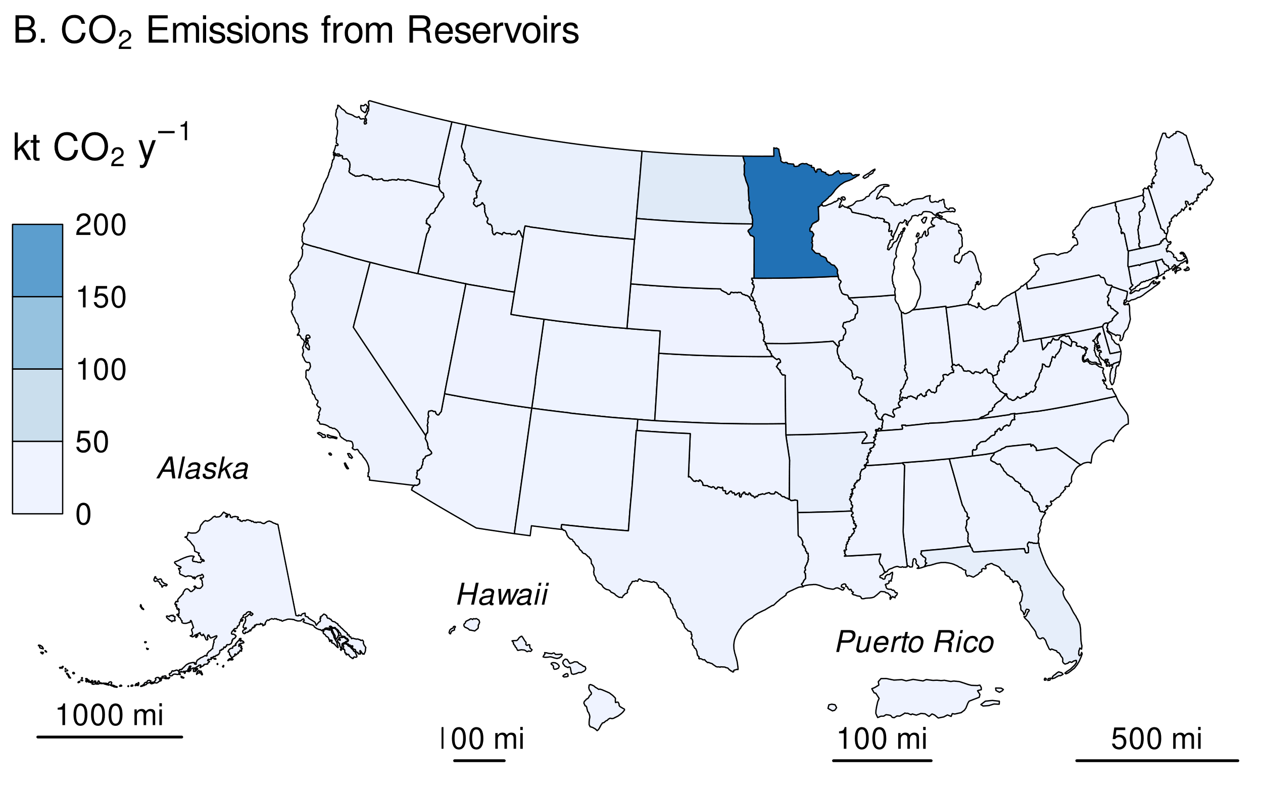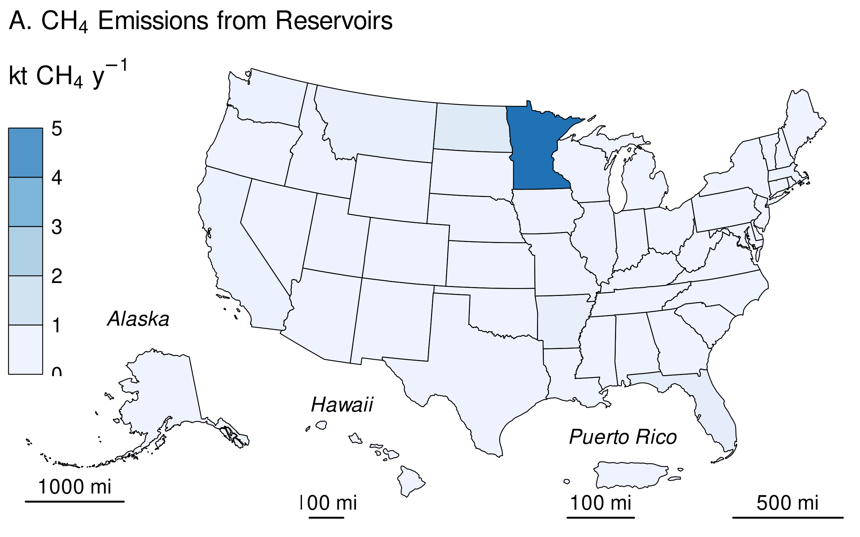

**Table 6‑105: Methane and CO2 Emissions from Reservoirs in Land Converted to Flooded Land in 2022 (kt CH4; kt CO2)**

|  |  |  |  |  |  |
| --- | --- | --- | --- | --- | --- |
|  | **CH4** | | |  | **CO2a** |
| **State** | **Surface** | **Downstream** | **Total** |  | **Surface** |
| Alabama | 0 | 0 | 0 |  | 0 |
| Alaska | 0 | 0 | 0 |  | 0 |
| Arizona | 0 | 0 | 0 |  | 0 |
| Arkansas | + | + | + |  | 9 |
| California | + | + | + |  | 3 |
| Colorado | + | + | + |  | 1 |
| Connecticut | + | + | + |  | + |
| Delaware | 0 | 0 | 0 |  | 0 |
| District of Columbia | 0 | 0 | 0 |  | 0 |
| Florida | + | + | + |  | 13 |
| Georgia | + | + | + |  | 1 |
| Hawaii | 0 | 0 | 0 |  | 0 |
| Idaho | + | + | + |  | 2 |
| Illinois | + | + | + |  | 4 |
| Indiana | + | + | + |  | + |
| Iowa | + | + | + |  | 2 |
| Kansas | + | + | + |  | + |
| Kentucky | 0 | 0 | 0 |  | 0 |
| Louisiana | + | + | + |  | + |
| Maine | + | + | + |  | + |
| Maryland | + | + | + |  | + |
| Massachusetts | + | + | + |  | 5 |
| Michigan | + | + | + |  | + |
| Minnesota | 5 | + | 5 |  | 202 |
| Mississippi | + | + | + |  | + |
| Missouri | + | + | + |  | 2 |
| Montana | + | + | + |  | 8 |
| Nebraska | + | + | + |  | 1 |
| Nevada | + | + | + |  | + |
| New Hampshire | + | + | + |  | 1 |
| New Jersey | 0 | 0 | 0 |  | 0 |
| New Mexico | + | + | + |  | 1 |
| New York | + | + | + |  | + |
| North Carolina | + | + | + |  | 1 |
| North Dakota | + | + | 1 |  | 22 |
| Ohio | + | + | + |  | 1 |
| Oklahoma | 0 | 0 | 0 |  | 0 |
| Oregon | + | + | + |  | 1 |
| Pennsylvania | + | + | + |  | 1 |
| Puerto Rico | 0 | 0 | 0 |  | 0 |
| Rhode Island | 0 | 0 | 0 |  | 0 |
| South Carolina | 0 | 0 | 0 |  | 0 |
| South Dakota | + | + | + |  | + |
| Tennessee | + | + | + |  | 1 |
| Texas | + | + | + |  | 3 |
| Utah | + | + | + |  | 1 |
| Vermont | 0 | 0 | 0 |  | 0 |
| Virginia | 0 | 0 | 0 |  | 0 |
| Washington | + | + | + |  | 3 |
| West Virginia | + | + | + |  | + |
| Wisconsin | + | + | + |  | 1 |
| Wyoming | + | + | + |  | 1 |
| + Indicates values greater than zero and less than 0.5 kt.  a CO2: Only surface CO2 emissions are included in the *Inventory.* | | | | | |

**Methodology and Time-Series Consistency**

Estimates of CH4 and CO2 emissions for reservoirs in land converted to flooded land follow the Tier 1 methodology in the IPCC guidance (IPCC 2019). All calculations are performed at the state level and summed to obtain national estimates. Emissions from the surface of these flooded lands are calculated as the product of flooded land surface area and a climate-specific emission factor (Table 6‑106). Downstream CH4 emissions are calculated as 9 percent of the surface CH4 emission (Tier 1 default). The IPCC guidance (IPCC 2019) does not address downstream CO2 emissions, presumably because there are insufficient data in the literature to estimate this emission pathway.

The IPCC default surface emission factors are derived from model-predicted (G-res model, Prairie et al. 2017) emission rates for all reservoirs in the Global Reservoir and Dam (GRanD) database (Lehner et al. 2011). Predicted emission rates were aggregated by the 11 IPCC climate zones (IPCC 2019, Table 7A.2) which were collapsed into six climate zones using a regression tree approach. All six aggregated climate zones are present in the United States.

**Table 6‑106: IPCC (2019) Default CH4 and CO2 Emission Factors for Surface Emissions from Reservoirs in Land Converted to Flooded Land**

|  |  |  |
| --- | --- | --- |
|  | **Surface emission factor** | |
| **Climate** | **MT CH4 ha-1 y-1** | **MT CO2 ha-1 y-1** |
| Boreal | 0.0277 | 3.45 |
| Cool Temperate | 0.0847 | 3.74 |
| Warm Temperate Dry | 0.1956 | 6.23 |
| Warm Temperate Moist | 0.1275 | 5.35 |
| Tropical Dry/Montane | 0.3923 | 10.82 |
| Tropical Moist/Wet | 0.2516 | 10.16 |
| Note: Downstream CH4 emissions are calculated as 9 percent of surface emissions. Downstream emissions are not calculated for CO2. | | |

*Area estimates*

U.S. reservoirs were identified from the NHDWaterbody layer in the National Hydrography Dataset Plus V2 (NHD),[1] the National Inventory of Dams (NID),[2] the National Wetlands Inventory (NWI),[3] and the Navigable Waterways (NW) network,[4] and the EPA’s Safe Drinking Water Information System (SDWIS).[5] The NHD only covers the conterminous United States, whereas the NID, NW and NWI also include Alaska, Hawaii, and Puerto Rico. The following paragraphs present the criteria used to identify other constructed waterbodies in the NHD, NW, and NWI.

Waterbodies in the NHDWaterbody layer that were less than or equal to 20-years old, greater than or equal to 8 ha in surface area, not identified as canal/ditch in NHD, and met any of the following criteria were considered reservoirs in land converted to flooded land: 1) the waterbody was classified “Reservoir” in the NHDWaterbody layer, 2) the waterbody name in the NHDWaterbody layer included “Reservoir”, 3) the waterbody in the NHDWaterbody layer was located in close proximity (up to 100 m) to a dam in the NID, 4) the NHDWaterbody GNIS name was similar to nearby NID feature (between 100 m to 1000 m).

EPA assumes that all features included in the NW are subject to water-level management to maintain minimum water depths required for navigation and are therefore managed flooded lands. NW features greater than 8 ha in surface area are defined as reservoirs.

NWI features were considered “managed” if they had a special modifier value indicating the presence of management activities (Figure 6‑19). To be included in the flooded lands inventory, the managed flooded land had to be wet or saturated for at least one season per year (see ‘Water Regime’ in Figure 6‑19). NWI features that met these criteria, were greater than 8 ha in surface area, and were not a canal/ditch (see emissions from land converted to flooded land–other constructed waterbodies) were defined as reservoirs.

Any NWI or NHD feature that intersected a drinking water intake point from SDWIS was assumed to be “managed.” The rational being that a waterbody used as a source for public drinking water is typically managed in some capacity - by flow and/or volume control.

Surface areas for identified flooded lands were taken from NHD, NWI or the NW. If features from the NHD, NWI, or the NW datasets overlapped, duplicate areas were erased. The first step was to take the final NWI flooded lands features and use it to identify overlapping NHD features. If the NHD feature had its center in a NWI feature, it was removed from analysis. Next, remaining NHD features were erased from any remaining overlapping NWI features. Final selections of NHD and NWI features were used to erase any overlapping NW waterbodies.

Reservoir age was determined by assuming they were created the same year as a nearby (up to 100 m) NID feature. If no nearby NID feature was identified, it was assumed the feature was greater than 20-years old throughout the time series. Only reservoirs less than or equal to 20-years old are included in land converted to flooded land.

**Figure 6‑19: Selected Features from NWI that meet Flooded Lands Criteria**

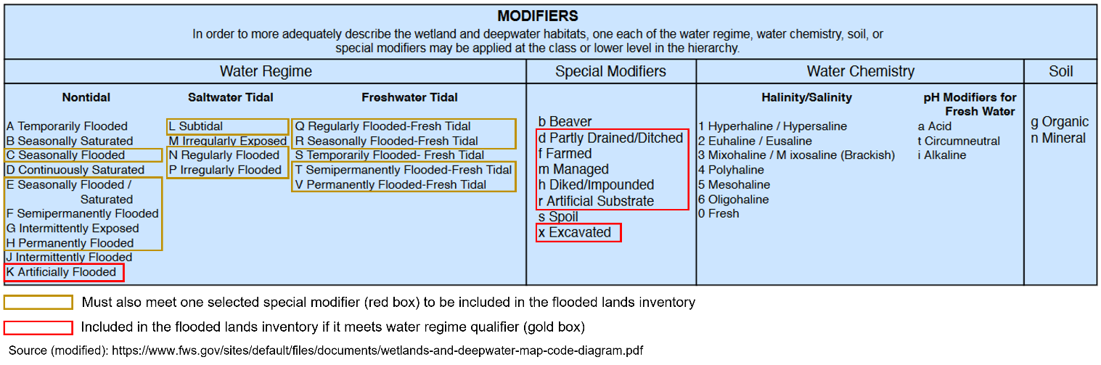

IPCC (2019) allows for the exclusion of managed waterbodies from the inventory if the water surface area or residence time was not substantially changed by the construction of the dam. The guidance does not quantify what constitutes a “substantial” change, but here EPA excludes the U.S. Great Lakes from the inventory based on expert judgment that neither the surface area nor water residence time was substantially altered by their associated dams.

Reservoirs were disaggregated by state (using boundaries from the 2016 U.S. Census Bureau[6]) and climate zone. Downstream and surface emissions for cross-state reservoirs were allocated to states based on the surface area that the reservoir occupied in each state. Only the U.S. portion of reservoirs that cross country borders were included in the *Inventory*.

The surface area of reservoirs in land converted to flooded land decreased by nearly 90 percent from 1990 to 2022 (Table 6‑107). This is due to reservoirs that were less than 20-years old at the beginning of time series entering the flooded land remaining flooded land category when they exceeded 20 years of age. The rate at which flooded land has aged out of the land converted to flooded land category has outpaced the rate of new dam construction. New dam construction has slowed considerably during the time series with only nine new dams constructed in 2022,[7] versus 552 in 1990 (Figure 6‑20).

**Table 6‑107: National Totals of Reservoir Surface Area in Land Converted to Flooded Land (thousands of ha)**

|  |  |  |  |  |  |  |  |
| --- | --- | --- | --- | --- | --- | --- | --- |
| **Surface Area (thousands of ha)** | **1990** | **2005** | **2018** | **2019** | **2020** | **2021** | **2022** |
| Reservoir | 566 | 115 | 78 | 77 | 75 | 74 | 73 |

**Figure 6‑20: Number of Dams Built per Year from 1990 through 2022**

Figure 6-20 is a line graph showing the number of dams built per year from 1990 through 2022. The number of dams remained high from 1990 to 2004 with between 350 and 600 dams built per year. There has been a steep drop off since 2004 with practically no new dams built in 2022.

**Table 6‑108: State Breakdown of Reservoir Surface Area in Land Converted to Flooded Land (thousands of ha)**

|  |  |  |  |  |  |  |  |
| --- | --- | --- | --- | --- | --- | --- | --- |
| **State** | **1990** | **2005** | **2018** | **2019** | **2020** | **2021** | **2022** |
| Alabama | 7.5 | 0.0 | 0.0 | 0.0 | 0.0 | 0.0 | 0.0 |
| Alaska | 0.6 | 0.0 | 0.0 | 0.0 | 0.0 | 0.0 | 0.0 |
| Arizona | 0.0 | 0.1 | 0.0 | 0.0 | 0.0 | 0.0 | 0.0 |
| Arkansas | 10.1 | 2.9 | 1.8 | 1.8 | 1.8 | 1.8 | 1.8 |
| California | 19.6 | 2.1 | 0.5 | 0.5 | 0.5 | 0.5 | 0.5 |
| Colorado | 5.9 | 1.3 | 0.3 | 0.3 | 0.3 | 0.3 | 0.3 |
| Connecticut | 2.3 | 2.2 | 0.0 | 0.0 | 0.0 | 0.0 | 0.0 |
| Delaware | 0.0 | 0.0 | 0.0 | 0.0 | 0.0 | 0.0 | 0.0 |
| District of Columbia | 0.0 | 0.0 | 0.0 | 0.0 | 0.0 | 0.0 | 0.0 |
| Florida | 25.7 | 3.8 | 1.5 | 1.5 | 1.4 | 1.2 | 1.2 |
| Georgia | 20.6 | 4.9 | 0.1 | 0.1 | 0.1 | 0.1 | 0.1 |
| Hawaii | 0.0 | 0.0 | 0.0 | 0.0 | 0.0 | 0.0 | 0.0 |
| Idaho | 17.7 | 1.2 | 0.5 | 0.5 | 0.5 | 0.5 | 0.5 |
| Illinois | 49.2 | 39.4 | 1.4 | 1.3 | 1.3 | 0.8 | 0.8 |
| Indiana | 10.6 | 0.3 | 0.1 | 0.1 | 0.1 | 0.1 | 0.1 |
| Iowa | 12.3 | 3.1 | 1.0 | 1.0 | 0.7 | 0.7 | 0.5 |
| Kansas | 19.6 | 0.4 | 0.2 | 0.2 | 0.1 | 0.1 | 0.0 |
| Kentucky | 1.3 | 0.1 | 0.0 | 0.0 | 0.0 | 0.0 | 0.0 |
| Louisiana | 9.4 | 0.2 | 0.0 | 0.0 | 0.0 | 0.0 | 0.0 |
| Maine | 10.9 | 4.4 | 0.0 | 0.0 | 0.0 | 0.0 | 0.0 |
| Maryland | 0.8 | 0.1 | 0.1 | 0.1 | 0.1 | 0.1 | 0.1 |
| Massachusetts | 1.6 | 0.5 | 1.5 | 1.5 | 1.4 | 1.4 | 1.2 |
| Michigan | 11.6 | 0.9 | 0.1 | 0.1 | 0.1 | 0.1 | 0.1 |
| Minnesota | 9.9 | 6.4 | 54.6 | 54.6 | 54.3 | 54.2 | 54.1 |
| Mississippi | 6.2 | 0.6 | 0.1 | 0.1 | 0.1 | 0.1 | 0.1 |
| Missouri | 16.4 | 0.5 | 0.4 | 0.4 | 0.4 | 0.4 | 0.4 |
| Montana | 14.4 | 3.9 | 2.1 | 2.1 | 2.1 | 2.1 | 2.1 |
| Nebraska | 5.8 | 1.7 | 0.6 | 0.6 | 0.3 | 0.3 | 0.3 |
| Nevada | 1.6 | 1.1 | 0.1 | 0.1 | 0.1 | 0.1 | 0.1 |
| New Hampshire | 0.4 | 0.2 | 0.1 | 0.1 | 0.1 | 0.1 | 0.1 |
| New Jersey | 0.7 | 0.6 | 0.0 | 0.0 | 0.0 | 0.0 | 0.0 |
| New Mexico | 1.3 | 0.1 | 0.1 | 0.1 | 0.1 | 0.1 | 0.1 |
| New York | 4.2 | 2.6 | 0.1 | 0.1 | 0.1 | 0.1 | 0.1 |
| North Carolina | 19.7 | 0.7 | 0.3 | 0.2 | 0.2 | 0.2 | 0.2 |
| North Dakota | 7.5 | 3.5 | 6.3 | 6.3 | 6.3 | 6.2 | 5.9 |
| Ohio | 7.2 | 1.3 | 0.3 | 0.3 | 0.2 | 0.2 | 0.1 |
| Oklahoma | 28.7 | 0.2 | 0.0 | 0.0 | 0.0 | 0.0 | 0.0 |
| Oregon | 6.2 | 0.4 | 0.2 | 0.2 | 0.2 | 0.1 | 0.1 |
| Pennsylvania | 12.6 | 1.3 | 0.1 | 0.1 | 0.1 | 0.1 | 0.1 |
| Puerto Rico | 0.0 | 0.0 | 0.0 | 0.0 | 0.0 | 0.0 | 0.0 |
| Rhode Island | 0.1 | 0.0 | 0.0 | 0.0 | 0.0 | 0.0 | 0.0 |
| South Carolina | 18.5 | 5.8 | 0.0 | 0.0 | 0.0 | 0.0 | 0.0 |
| South Dakota | 0.5 | 3.9 | 0.8 | 0.8 | 0.0 | 0.0 | 0.0 |
| Tennessee | 58.7 | 0.0 | 0.1 | 0.1 | 0.1 | 0.1 | 0.1 |
| Texas | 74.8 | 0.9 | 0.3 | 0.3 | 0.2 | 0.2 | 0.2 |
| Utah | 1.9 | 0.1 | 0.3 | 0.3 | 0.3 | 0.3 | 0.3 |
| Vermont | 0.2 | 0.1 | 0.0 | 0.0 | 0.0 | 0.0 | 0.0 |
| Virginia | 5.8 | 0.4 | 0.0 | 0.0 | 0.0 | 0.0 | 0.0 |
| Washington | 5.3 | 1.6 | 0.9 | 0.9 | 0.5 | 0.5 | 0.5 |
| West Virginia | 3.1 | 1.6 | 0.1 | 0.0 | 0.0 | 0.0 | 0.0 |
| Wisconsin | 1.9 | 0.4 | 0.2 | 0.2 | 0.2 | 0.2 | 0.2 |
| Wyoming | 15.1 | 6.5 | 0.4 | 0.2 | 0.2 | 0.2 | 0.2 |
| **Total** | **565.8** | **114.6** | **77.6** | **77.1** | **74.7** | **73.7** | **72.5** |

**Uncertainty**

Uncertainty in estimates of CH4 and CO2 emissions from reservoirs on land converted to flooded land were developed using IPCC Approach 2 and include uncertainty in the default emission factors and the flooded land area inventory (Table 1-105). Uncertainty in emission factors is provided in the *2019 Refinement to the 2006 IPCC Guidelines* (IPCC 2019). Uncertainties in the spatial data include 1) uncertainty in area estimates from the NHD, NWI, and NW, and 2) uncertainty in the location of dams in the NID and drinking water intakes in SDWIS. Overall uncertainties in these spatial datasets are unknown, but uncertainty for remote sensing products is assumed to be ± 10 to 15 percent based on IPCC guidance (IPCC 2003). An uncertainty range of ± 15 percent for the flooded land area estimates is assumed and is based on expert judgment.

**Table 6‑109: Approach 2 Quantitative Uncertainty Estimates for CH4 and CO2 Emissions from Reservoirs in Land Converted to Flooded Land**

|  |  |  |  |  |  |  |
| --- | --- | --- | --- | --- | --- | --- |
| **Source** | **Gas** | **2022 Emission Estimate** | **Uncertainty Range Relative to Emission Estimatea** | | | |
| **(MMT CO2 Eq.)** | **(MMT CO2 Eq.)** | | **(%)** | |
|  |  |  | **Lower Bound** | **Upper Bound** | **Lower Bound** | **Upper Bound** |
| **Reservoir** |  |  |  |  |  |  |
| Surface | CH4 | 0.19 | 0.17 | 0.21 | -11.5% | +11.9% |
| Surface | CO2 | 0.2 | 0.26 | 0.33 | -11.7% | +12.4% |
| Downstream | CH4 | + | + | 0.08 | -54.1% | +397.0% |
| **Total** |  | **0.5** | **0.44** | **0.59** | **-12.2%** | **+18.8%** |
| + Indicates values less than 0.05 MMT CO2 Eq.  aRange of emission estimates predicted by Monte Carlo stochastic simulation for a 95 percent confidence interval. | | | | | | |

**QA/QC and Verification**

The National Hydrography Data (NHD) is managed by the USGS in collaboration many other federal, state, and local entities. Extensive QA/QC procedures are incorporated into the curation of the NHD. The National Inventory of Dams (NID) is maintained by the U.S. Army Corps of Engineers (USACE) in collaboration with the Federal Emergency Management Agency (FEMA) and state regulatory offices. USACE resolves duplicative and conflicting data from 68 data sources, which helps obtain the more complete, accurate, and updated NID. The Navigable Waterways (NW) dataset is part of the U.S. Department of Transportation (USDOT)/Bureau of Transportation Statistics (BTS) National Transportation Atlas Database (NTAD). The NW is a comprehensive network database of the nation's navigable waterways updated on a continuing basis. U.S. Fish and Wildlife Service is the principal agency in charge of wetland mapping including the National Wetlands Inventory (NWI). Quality and consistency of the Wetlands Layer is supported by federal wetlands mapping and classification [standards](https://www.fws.gov/program/national-wetlands-inventory/data-standards), which were developed under the oversight of the Federal Geographic Data Committee (FGDC) with input by the [FGDC Wetlands Subcommittee](https://www.fgdc.gov/organization/working-groups-subcommittees/wsc/index_html). This dataset is part of the FGDC [Water-Inland Theme](https://www.geoplatform.gov/ngda/waterinland), which is co-chaired by the FWS and the U.S. Geological Survey. The EPA's Safe Drinking Water Information System (SDWIS) tracks information on drinking water contamination levels as required by the 1974 Safe Drinking Water Act and its 1986 and 1996 amendments.

General QA/QC procedures were applied to activity data, documentation, and emission calculations consistent with the U.S. Inventory QA/QC plan, which is in accordance with Vol. 1 Chapter 6 of the *2006* *IPCC* *Guidelines* (see Annex 8 for more details). All calculations were executed independently in Excel and R. Ten percent of state and national totals were randomly selected for comparison between the two approaches to ensure there were no computational errors.

**Recalculations Discussion**

The EPA's SDWIS is a new data source used in the current (1990 through 2022) *Inventory*. The assumption is that any waterbody used as a public drinking water source is managed in some capacity—by flow and/or volume control. This data source added 418 reservoirs totaling 736,344 ha.

The National Inventory of Dams (NID) data are updated regularly. The version of NID used for the current *Inventory* contains 47 new dams and updated values for “year of dam completion” for 975 dams relative to the previous (1990 through 2021) *Inventory* data. Similarly, the National Wetlands Inventory (NWI) is periodically updated. The NWI version used for the current 1990 through 2022 *Inventory* has major updates for MS, ND, NM, and MT.

Overall, the recalculations resulted in substantial increases in methane and carbon dioxide emissions in the first few years of the time series (e.g., increase of 3.8 MMT CO2 Eq. in 1990), but the differences were minor by 2008 through 2021 (<0.1 MMT CO2 Eq.).

**Planned Improvements**

The EPA recently completed a survey of greenhouse gas emissions from 108 reservoirs in the conterminous United States.[8] The data will be used to develop country-specific emission factors for U.S. reservoirs to be used in the 1990 through 2024 *Inventory* submission.

**Emissions from Land Converted to Flooded Land–Other Constructed Waterbodies**

Freshwater ponds are the only type of flooded lands within the “other constructed waterbodies” subcategory of land converted to flooded land that are included in this *Inventory* (see Methodology for details) because age data are not available for canals and ditches. All canals and ditches are assumed to be greater than 20-years old throughout the time series and are included in flooded land remaining flooded land.

IPCC (2019) describes ponds as waterbodies that are “…constructed by excavation and/or construction of walls to hold water in the landscape for a range of uses, including agricultural water storage, access to water for livestock, recreation, and aquaculture.” The IPCC “Decision tree for types of Flooded Land” (IPCC 2019, Fig. 7.2) elaborates on this description by defining waterbodies less than 8 ha as a subset of “other constructed waterbodies.” For this *Inventory*, ponds are defined as managed flooded land not identified as “canal/ditch” (see Methods below) with surface area less than 8 ha. IPCC (2019) further distinguishes saline versus brackish ponds, with the former supporting lower CH4 emission rates than the latter. Activity data on pond salinity is not uniformly available for the United States and all ponds in land converted to flooded land are assumed to be freshwater. Ponds often receive high organic matter and nutrient loadings, may have low oxygen levels, and are sites of substantial CH4 and CO2 emissions from anaerobic sediments.

Methane and CO2 emissions from freshwater ponds decreased 95 percent from 1990 to 2022 due to flooded land matriculating from land converted to flooded land to flooded land remaining flooded land. In 2022, states in the Great Plains region generally had the greatest CO2 and CH4 emissions from freshwater ponds in land converted to flooded land (Table 6‑110 through Table 6‑114, Figure 6‑21). Mississippi had the second greatest emissions of all states, partly due to the relatively high CO2 emission factor for the tropical moist/wet climate zone (Figure 6‑17, Table 6‑115).

**Table 6‑110: CH4 Emissions from Other Constructed Waterbodies in Land Converted to Flooded Land (MMT CO2 Eq.)**

|  |  |  |  |  |  |  |  |
| --- | --- | --- | --- | --- | --- | --- | --- |
| **Source** | **1990** | **2005** | **2018** | **2019** | **2020** | **2021** | **2022** |
| Freshwater Ponds | 0.1 | + | + | + | + | + | + |

+ Indicates values less than 0.05 MMT CO2 Eq.

**Table 6‑111: CH4 Emissions from Other Constructed Waterbodies in Land Converted to Flooded Land (kt CH4)**

|  |  |  |  |  |  |  |  |
| --- | --- | --- | --- | --- | --- | --- | --- |
| **Source** | **1990** | **2005** | **2018** | **2019** | **2020** | **2021** | **2022** |
| Freshwater Ponds | 5 | 1 | + | + | + | + | + |

+ Indicates values less than 0.5 kt.

**Table 6‑112: CO2 Emissions from Other Constructed Waterbodies in Land Converted to Flooded Land (MMT CO2 Eq.)**

|  |  |  |  |  |  |  |  |
| --- | --- | --- | --- | --- | --- | --- | --- |
| **Source** | **1990** | **2005** | **2018** | **2019** | **2020** | **2021** | **2022** |
| Freshwater Ponds | + | + | + | + | + | + | + |

+ Indicates values less than 0.05 MMT C.

**Table 6‑113: CO2 Emissions from Other Constructed Waterbodies in Land Converted to Flooded Land (MMT C)**

|  |  |  |  |  |  |  |  |
| --- | --- | --- | --- | --- | --- | --- | --- |
| **Source** | **1990** | **2005** | **2018** | **2019** | **2020** | **2021** | **2022** |
| Freshwater Ponds | 0.04 | 0.01 | + | + | + | + | + |

+ Indicates values less than 0.005 MMT C.

**Table 6‑114: CH4 and CO2 Emissions from Other Constructed Waterbodies inLand Converted to Flooded Land in 2022 (MT CO2 Eq.)**

|  |  |  |  |
| --- | --- | --- | --- |
|  | **Freshwater Ponds** | | |
| **State** | **CH4** | **CO2** | **Total** |
| Alabama | 0 | 0 | 0 |
| Alaska | 0 | 0 | 0 |
| Arizona | 0 | 0 | 0 |
| Arkansas | 1 | 1 | 3 |
| California | 126 | 146 | 272 |
| Colorado | 382 | 290 | 672 |
| Connecticut | 0 | 0 | 0 |
| Delaware | 0 | 0 | 1 |
| District of Columbia | 0 | 0 | 0 |
| Florida | 18 | 37 | 55 |
| Georgia | 164 | 293 | 457 |
| Hawaii | 0 | 0 | 0 |
| Idaho | 0 | 0 | 0 |
| Illinois | 83 | 74 | 157 |
| Indiana | 66 | 69 | 135 |
| Iowa | 282 | 254 | 535 |
| Kansas | 435 | 456 | 891 |
| Kentucky | 3 | 3 | 5 |
| Louisiana | 3 | 6 | 10 |
| Maine | 1 | 1 | 2 |
| Maryland | 58 | 60 | 118 |
| Massachusetts | 381 | 358 | 738 |
| Michigan | 41 | 30 | 71 |
| Minnesota | 317 | 232 | 549 |
| Mississippi | 400 | 612 | 1,012 |
| Missouri | 133 | 139 | 271 |
| Montana | 509 | 371 | 880 |
| Nebraska | 620 | 567 | 1,186 |
| Nevada | 103 | 80 | 183 |
| New Hampshire | 80 | 59 | 139 |
| New Jersey | 0 | 0 | 0 |
| New Mexico | 57 | 46 | 103 |
| New York | 120 | 96 | 215 |
| North Carolina | 107 | 112 | 219 |
| North Dakota | 229 | 167 | 396 |
| Ohio | 289 | 285 | 574 |
| Oklahoma | 339 | 378 | 717 |
| Oregon | 89 | 71 | 161 |
| Pennsylvania | 29 | 25 | 54 |
| Puerto Rico | 0 | 0 | 0 |
| Rhode Island | 0 | 0 | 0 |
| South Carolina | 47 | 49 | 95 |
| South Dakota | 455 | 332 | 788 |
| Tennessee | 11 | 11 | 22 |
| Texas | 83 | 138 | 222 |
| Utah | 207 | 151 | 359 |
| Vermont | 15 | 11 | 26 |
| Virginia | 10 | 11 | 21 |
| Washington | 140 | 132 | 272 |
| West Virginia | 19 | 19 | 38 |
| Wisconsin | 93 | 68 | 162 |
| Wyoming | 369 | 269 | 639 |
| **Total** | **6,917** | **6,510** | **13,427** |

**Figure 6‑21: 2022 A) CH4 and B) CO2 Emissions from Other Constructed Waterbodies (Freshwater Ponds) in Land Converted to Flooded Land (MT CO2 Eq.)**

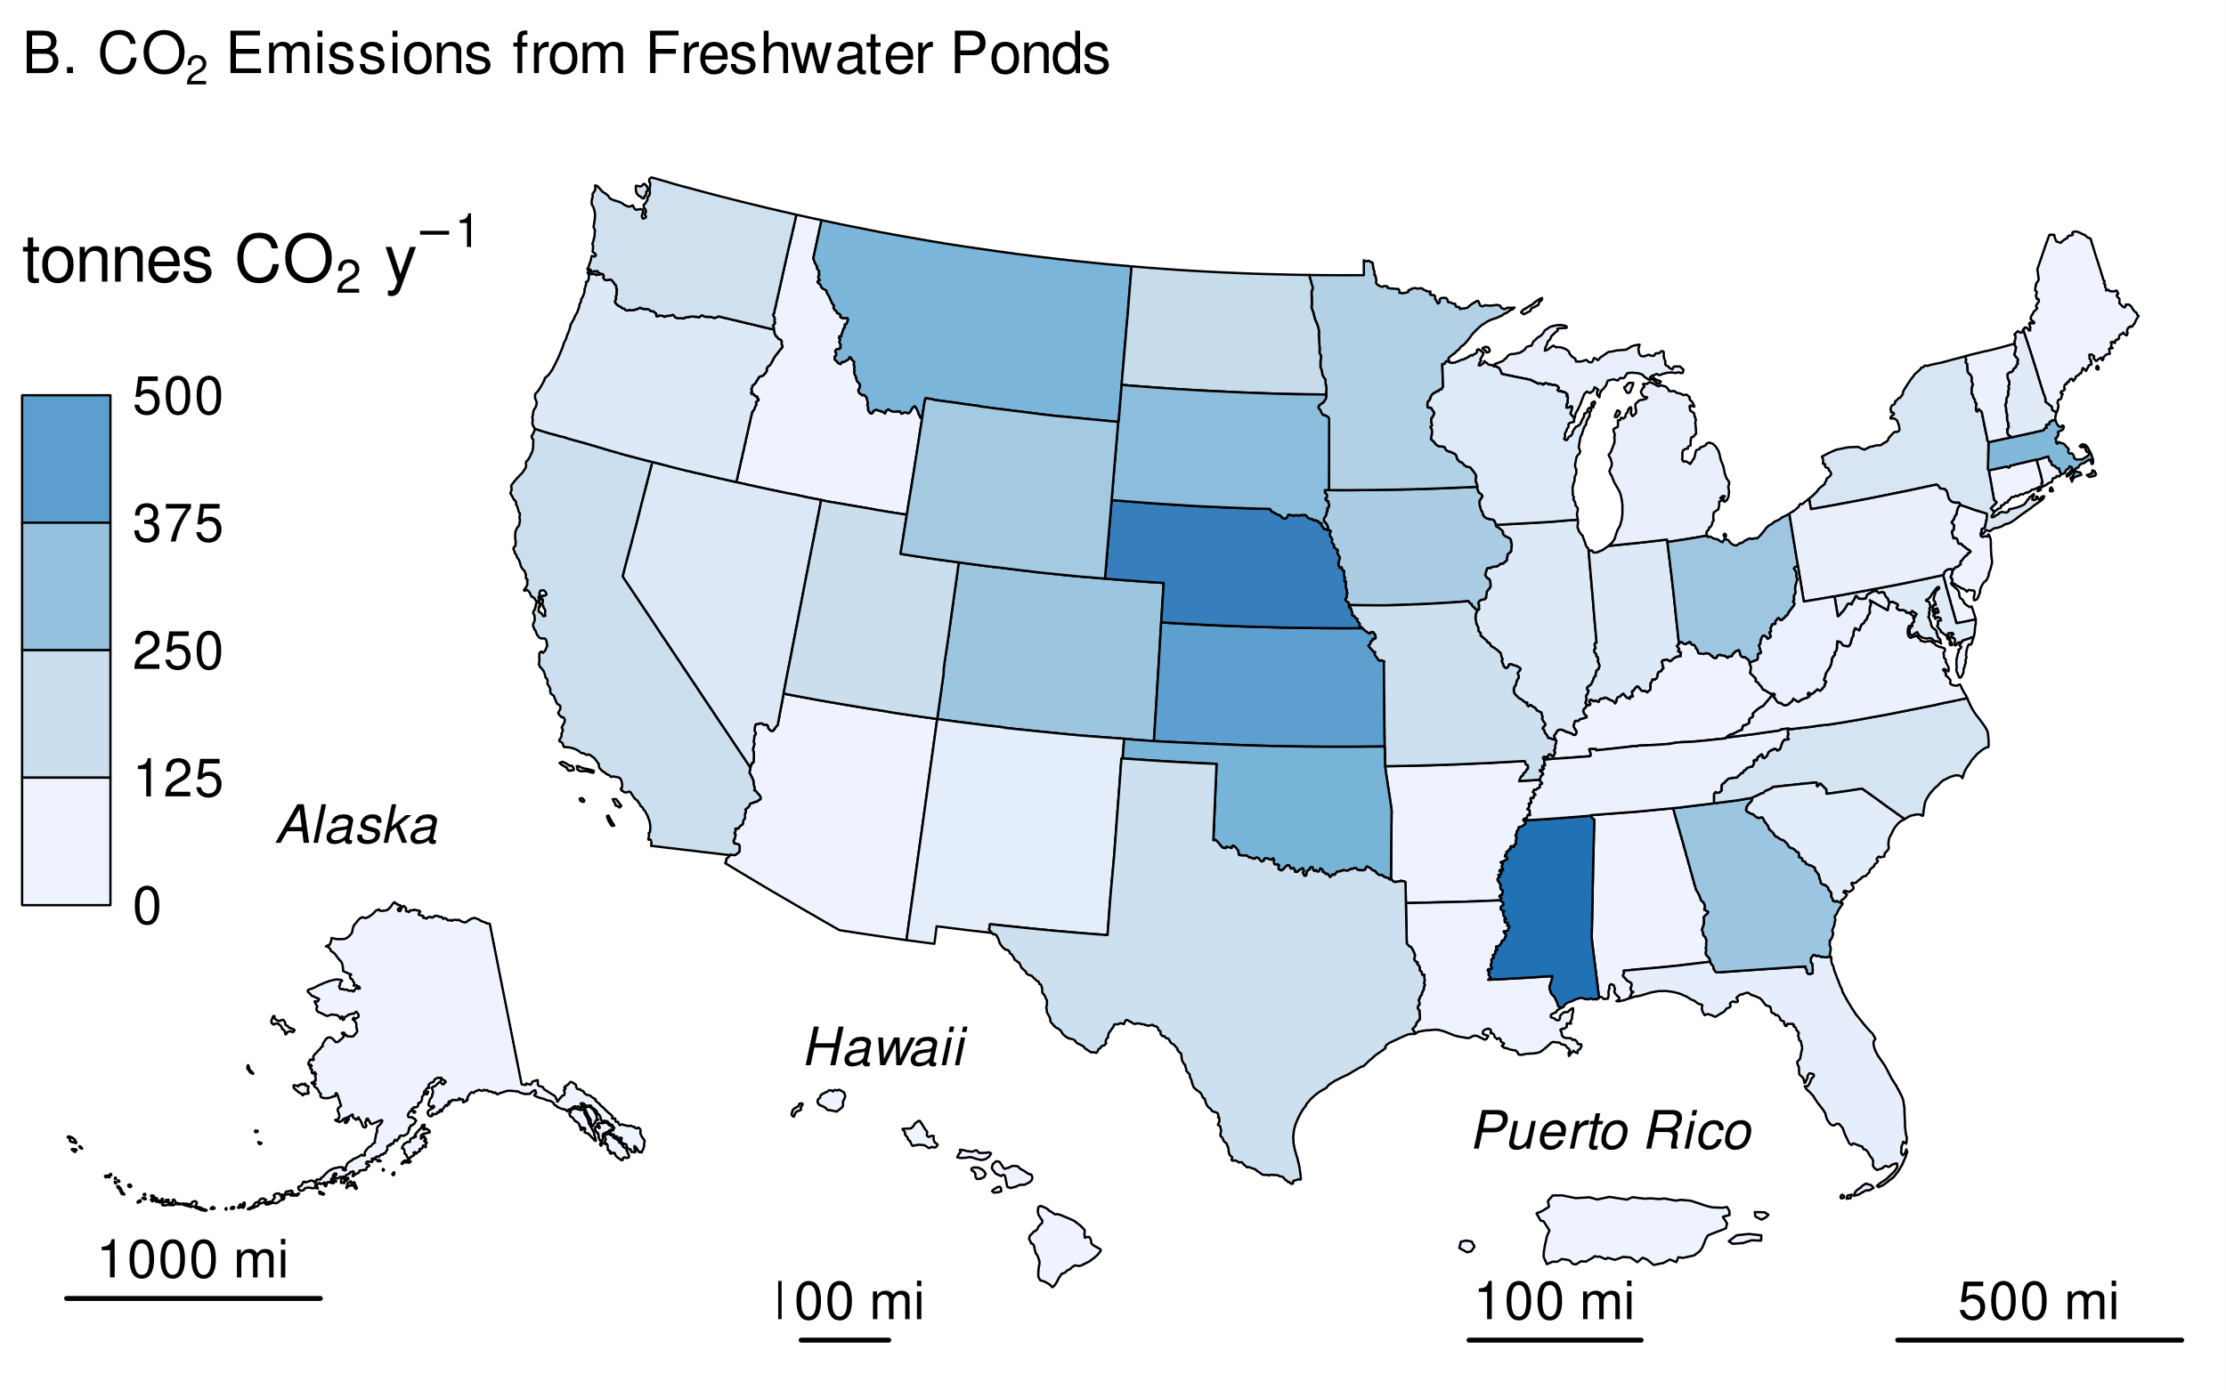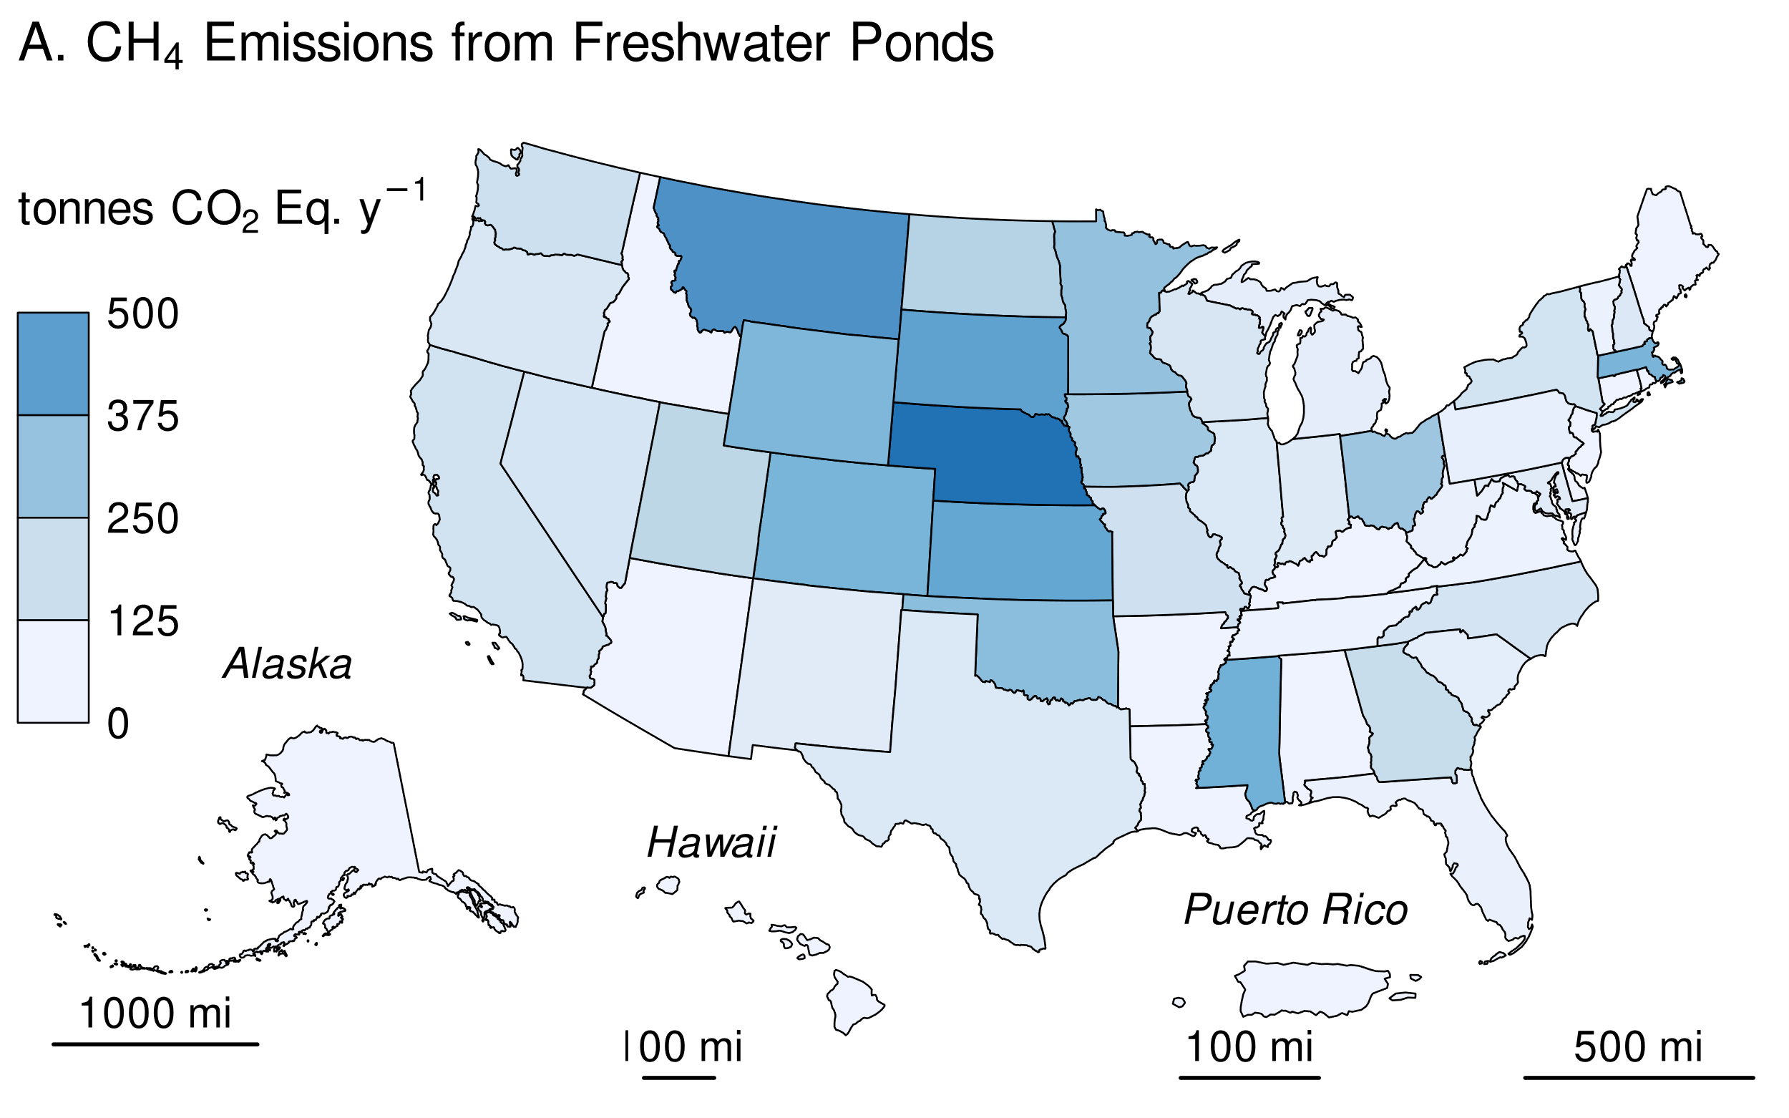

**Methodology and Time-Series Consistency**

Estimates of CH4 and CO2 emissions for other constructed waterbodies in land converted to flooded land follow the Tier 1 methodology in IPCC (2019). All calculations are performed at the state level and summed to obtain national estimates. Greenhouse gas emissions from the surface of these flooded lands are calculated as the product of flooded land surface area and an emission factor (Table 6‑115). Due to a lack of empirical data on CO2 emissions from recently created ponds, IPCC (2019) states “For all types of ponds created by damming, the methodology described above to estimate CO2 emissions from land converted to reservoirs may be used.” This *Inventory* uses IPCC default CO2 emission factors for land converted to reservoirs when estimating CO2 emissions from land converted to freshwater ponds. IPCC guidance also states that “there is insufficient information available to derive separate CH4 emission factors for recently constructed ponds…” and allows for the use of IPCC default CH4 emission factors for land remaining flooded land. Downstream emissions are not inventoried for other constructed waterbodies because 1) many of these systems are not associated with dams (e.g., excavated ponds and ditches), and 2) there are insufficient data to derive downstream emission factors for other constructed waterbodies that are associated with dams (IPCC 2019).

**Table 6‑115: IPCC Default Methane and CO2 Emission Factors for Other Constructed Waterbodies in Land Converted to Flooded Land**

|  |  |  |  |
| --- | --- | --- | --- |
|  |  | **Emission Factor** | |
| **Other Constructed Waterbody** | **Climate Zone** | **MT CH4 ha-1 y-1** | **MT CO2 ha-1 y-1** |
| Freshwater ponds | Boreal | 0.183 | 3.45 |
| Freshwater ponds | Cool Temperate | 0.183 | 3.74 |
| Freshwater ponds | Warm Temperate Dry | 0.183 | 6.23 |
| Freshwater ponds | Warm Temperate Moist | 0.183 | 5.35 |
| Freshwater ponds | Tropical Dry/Montane | 0.183 | 10.82 |
| Freshwater ponds | Tropical Moist/Wet | 0.183 | 10.16 |

*Area Estimates*

Other constructed waterbodies were identified from the NHDWaterbody layer in the National Hydrography Dataset Plus V2 (NHD),[9] the National Inventory of Dams (NID),[10] the National Wetlands Inventory (NWI),[11] and the Navigable Waterways (NW) network[12], and the EPA’s Safe Drinking Water Information System (SDWIS)[13]. The NHD only covers the conterminous United States, whereas the NID, NW and NWI also include Alaska, Hawaii, and Puerto Rico.

Waterbodies in the NHDWaterbody layer that were less than or equal to 20-years old, less than 8 ha in surface area, not identified as canal/ditch in NHD, and met any of the following criteria were considered freshwater ponds in land converted to flooded land: 1) the waterbody was classified “Reservoir” in the NHDWaterbody layer, 2) the waterbody name in the NHDWaterbody layer included “Reservoir”, 3) the waterbody in the NHDWaterbody layer was located in close proximity (up to 100 m) to a dam in the NID, 4) the NHDWaterbody GNIS name was similar to nearby NID feature (between 100 m to 1000 m).

EPA assumes that all features included in the NW are subject to water-level management to maintain minimum water depths required for navigation and are therefore managed flooded lands. NW features that were less than 8 ha in surface area and not identified as canals/ditch (see below) were considered freshwater ponds. Only 2.1 percent of NW features met these criteria, and they were primarily associated with larger navigable waterways, such as lock chambers on impounded rivers.

NWI features were considered “managed” if they had a special modifier value indicating the presence of management activities (Figure 6‑19). To be included in the flooded lands inventory, the managed flooded land had to be wet or saturated for at least one season per year (see ‘Water Regime’ in Figure 6‑19). NWI features that met these criteria, were less than 8 ha in surface area, and were not a canal/ditch were defined as freshwater ponds.

Any NWI or NHD feature that intersected a drinking water intake point from SDWIS was assumed to be “managed”. The rational being that a waterbody used as a source for public drinking water is typically managed in some capacity - by flow and/or volume control.

Surface areas for other constructed waterbodies were taken from NHD, NWI or the NW. If features from the NHD, NWI, or the NW datasets overlapped, duplicate areas were erased. The first step was to take the final NWI flooded lands features and use it to identify overlapping NHD features. If the NHD feature had its center in a NWI feature, it was removed from analysis. Next, remaining NHD features were erased from any remaining overlapping NWI features. Final selections of NHD and NWI features were used to erase any overlapping NW waterbodies.

The age of other constructed waterbody features was determined by assuming the waterbody was created the same year as a nearby (up to 100 m) NID feature. If no nearby NID feature was identified, it was assumed the waterbody was greater than 20-years old throughout the time series. No canal/ditch features were associated with a nearby dam, therefore all canal/ditch features were assumed to be greater than 20-years old through the time series.

For the year 2022, this *Inventory* contains 1,350 ha of freshwater ponds in land converted to flooded land. The surface area of freshwater ponds decreased by 95 percent from 1990 to 2022 due to flooded lands aging out of land converted to flooded land more quickly than new flooded lands entered the category. The greatest reduction in freshwater pond surface area occurred in Iowa, Kansas, and Georgia (Table 6‑117). Freshwater ponds in the 2021 inventory are most abundant in Nebraska, Montana, and Kansas (Figure 6‑22).

**Table 6‑116: National Surface Area Totals of Other Constructed Waterbodies in Land Converted to Flooded Land (ha)**

|  |  |  |  |  |  |  |  |
| --- | --- | --- | --- | --- | --- | --- | --- |
| **Other Constructed Waterbodies** | **1990** | **2005** | **2018** | **2019** | **2020** | **2021** | **2022** |
| Freshwater Ponds | 25,492 | 5,357 | 2,604 | 2,317 | 1,983 | 1,673 | 1,472 |

**Figure 6‑22: Surface Area of Other Constructed Waterbodies in Land Converted to Flooded Land (ha) in 2022**

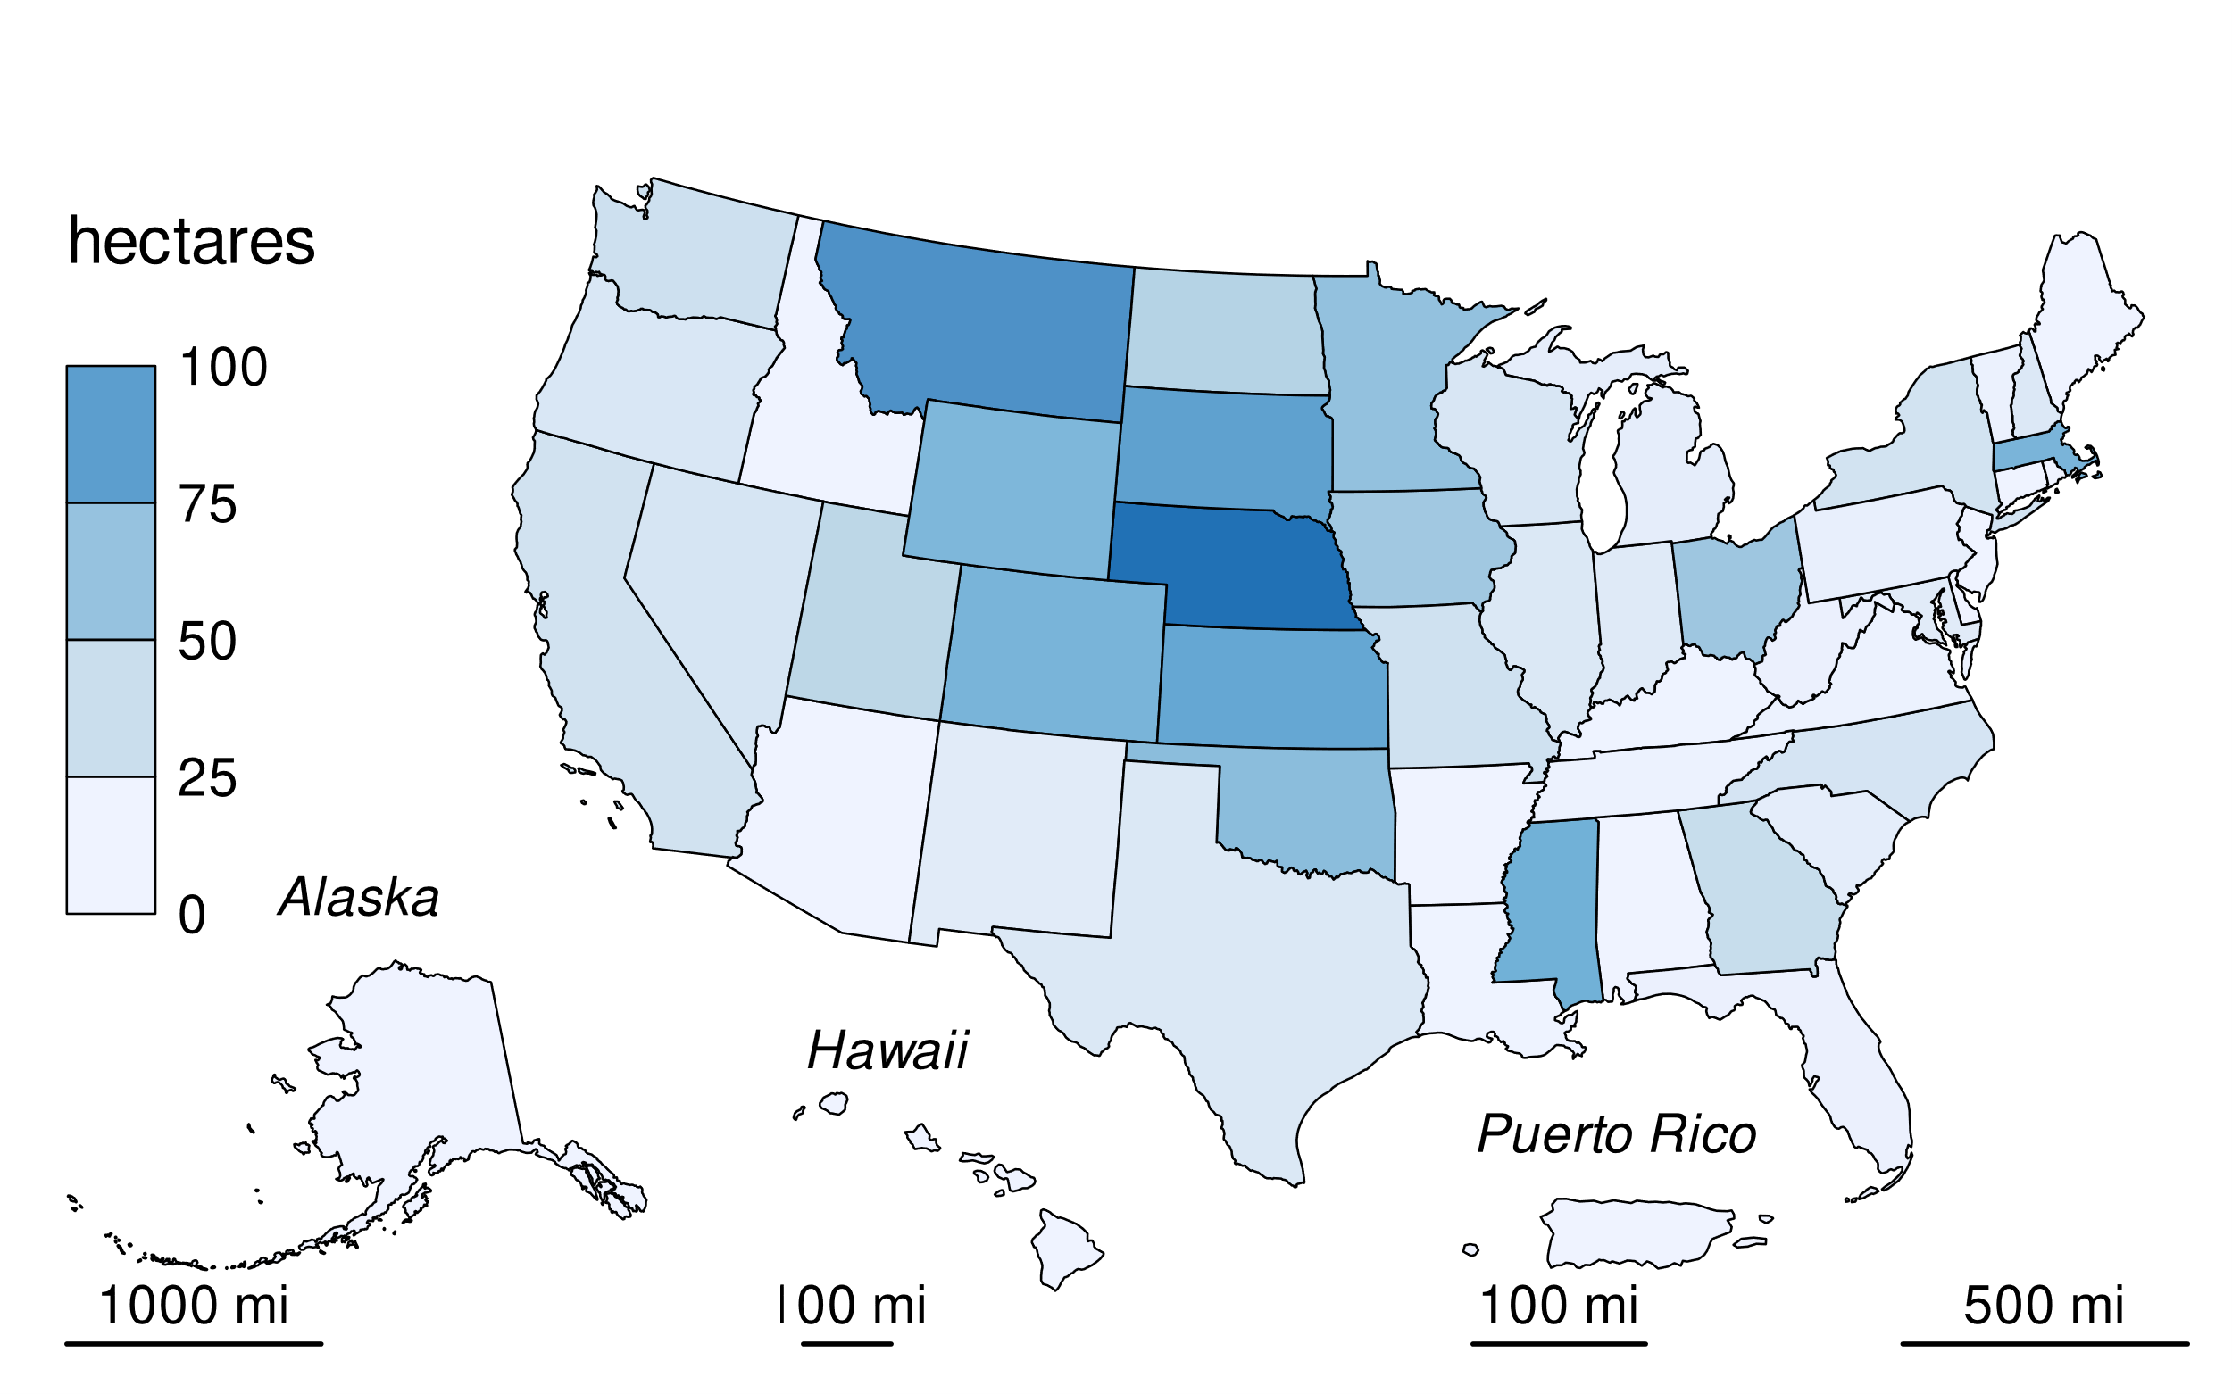

**Table 6‑117: State Surface Area Totals of Other Constructed Waterbodies in Land Converted to Flooded Land (ha)**

|  |  |  |  |  |  |  |  |
| --- | --- | --- | --- | --- | --- | --- | --- |
| **State** | **1990** | **2005** | **2018** | **2019** | **2020** | **2021** | **2022** |
| Alabama | 317 | 13 | 0 | 0 | 0 | 0 | 0 |
| Alaska | 3 | 0 | 0 | 0 | 0 | 0 | 0 |
| Arizona | 39 | 16 | 4 | 4 | 0 | 0 | 0 |
| Arkansas | 331 | 0 | 0 | 0 | 0 | 0 | 0 |
| California | 263 | 103 | 45 | 40 | 33 | 31 | 25 |
| Colorado | 279 | 71 | 79 | 78 | 89 | 89 | 75 |
| Connecticut | 67 | 2 | 0 | 0 | 0 | 0 | 0 |
| Delaware | 4 | 0 | 0 | 0 | 0 | 0 | 0 |
| District of Columbia | 0 | 0 | 0 | 0 | 0 | 0 | 0 |
| Florida | 154 | 58 | 15 | 10 | 10 | 4 | 4 |
| Georgia | 1,686 | 83 | 35 | 32 | 32 | 32 | 32 |
| Hawaii | 11 | 4 | 0 | 0 | 0 | 0 | 0 |
| Idaho | 133 | 8 | 1 | 1 | 1 | 0 | 0 |
| Illinois | 557 | 133 | 42 | 37 | 27 | 26 | 16 |
| Indiana | 494 | 133 | 28 | 23 | 23 | 23 | 13 |
| Iowa | 2,592 | 1,580 | 474 | 290 | 172 | 76 | 55 |
| Kansas | 2,099 | 147 | 113 | 104 | 103 | 87 | 85 |
| Kentucky | 394 | 30 | 1 | 1 | 1 | 1 | 1 |
| Louisiana | 130 | 17 | 7 | 7 | 1 | 1 | 1 |
| Maine | 51 | 10 | 0 | 0 | 0 | 0 | 0 |
| Maryland | 226 | 81 | 20 | 20 | 18 | 15 | 11 |
| Massachusetts | 68 | 79 | 93 | 86 | 80 | 78 | 74 |
| Michigan | 162 | 37 | 16 | 16 | 8 | 8 | 8 |
| Minnesota | 344 | 142 | 103 | 101 | 79 | 71 | 62 |
| Mississippi | 414 | 200 | 124 | 117 | 98 | 85 | 78 |
| Missouri | 3,451 | 104 | 38 | 34 | 32 | 29 | 26 |
| Montana | 400 | 109 | 105 | 100 | 99 | 99 | 99 |
| Nebraska | 1,427 | 374 | 182 | 164 | 133 | 125 | 121 |
| Nevada | 21 | 64 | 26 | 26 | 22 | 22 | 20 |
| New Hampshire | 154 | 61 | 17 | 17 | 16 | 16 | 16 |
| New Jersey | 50 | 21 | 0 | 0 | 0 | 0 | 0 |
| New Mexico | 14 | 14 | 19 | 17 | 17 | 17 | 11 |
| New York | 312 | 124 | 31 | 29 | 29 | 24 | 23 |
| North Carolina | 498 | 92 | 28 | 28 | 25 | 22 | 21 |
| North Dakota | 90 | 135 | 67 | 61 | 51 | 48 | 45 |
| Ohio | 431 | 293 | 121 | 107 | 75 | 60 | 56 |
| Oklahoma | 2,008 | 147 | 111 | 95 | 81 | 75 | 66 |
| Oregon | 220 | 69 | 25 | 22 | 18 | 17 | 17 |
| Pennsylvania | 255 | 33 | 6 | 6 | 6 | 6 | 6 |
| Puerto Rico | 0 | 0 | 0 | 0 | 0 | 0 | 0 |
| Rhode Island | 9 | 7 | 0 | 0 | 0 | 0 | 0 |
| South Carolina | 826 | 230 | 22 | 13 | 9 | 9 | 9 |
| South Dakota | 227 | 98 | 105 | 94 | 93 | 89 | 89 |
| Tennessee | 389 | 37 | 14 | 9 | 2 | 2 | 2 |
| Texas | 2,950 | 89 | 21 | 16 | 17 | 16 | 16 |
| Utah | 68 | 19 | 42 | 42 | 40 | 40 | 40 |
| Vermont | 70 | 11 | 3 | 3 | 3 | 3 | 3 |
| Virginia | 58 | 4 | 2 | 2 | 2 | 2 | 2 |
| Washington | 153 | 57 | 31 | 31 | 28 | 27 | 27 |
| West Virginia | 130 | 10 | 4 | 4 | 4 | 4 | 4 |
| Wisconsin | 146 | 21 | 18 | 18 | 18 | 18 | 18 |
| Wyoming | 316 | 190 | 79 | 79 | 78 | 75 | 72 |
| **Total** | **25,492** | **5,357** | **2,317** | **1,983** | **1,673** | **1,472** | **1,350** |

**Uncertainty**

Uncertainty in estimates of CO2 and CH4 emissions from land converted to flooded land–other constructed water bodies include uncertainty in the default emission factors and the flooded land area inventory. Uncertainty in emission factors is provided in the *2019 Refinement to the 2006 IPCC Guidelines* (IPCC 2019). Uncertainties in the spatial data include 1) uncertainty in area estimates from the NHD and NW, and 2) uncertainty in the location of dams in the NID and drinking water intakes in SDWIS. Overall uncertainties in the NHD, NWI, NID, and NW are unknown, but uncertainty for remote sensing products is ±10 to 15 percent (IPCC 2003). EPA assumes an uncertainty of ± 15 percent for the flooded land area inventory based on expert judgment. These uncertainties do not include the underestimate of pond surface area discussed above.

**Table 6‑118: Approach 2 Quantitative Uncertainty Estimates for CH4 and CO2 Emissions from Other Constructed Waterbodies in Land Converted to Flooded Land**

|  |  |  |  |  |  |  |
| --- | --- | --- | --- | --- | --- | --- |
| **Source** | **Gas** | **2022 Emission Estimate** | **Uncertainty Range Relative to Emission Estimatea** | | | |
| **(kt CO2 Eq.)** | **(kt CO2 Eq.)** | | **(%)** | |
|  |  |  | **Lower Bound** | **Upper Bound** | **Lower Bound** | **Upper Bound** |
| Freshwater ponds | CH4 | 6.90 | 6.80 | 7.10 | -2.3% | +2.7% |
| Freshwater ponds | CO2 | 6.51 | 6.38 | 6.62 | -2.0% | +1.8% |
| **Total** |  | **13.42** | **13.18** | **13.70** | **-1.8**% | **+2.1**% |
| a Range of emission estimates predicted by Monte Carlo stochastic simulation for a 95 percent confidence interval.  Note: Totals may not sum due to independent rounding. | | | | | | |

**QA/QC and Verification**

The National Hydrography Data (NHD) is managed by the USGS with collaboration from many other federal, state, and local entities. Extensive QA/QC procedures are incorporated into the curation of the NHD. The National Inventory of Dams (NID) is maintained by the U.S. Army Corps of Engineers (USACE) in collaboration with the Federal Emergency Management Agency (FEMA) and state regulatory offices. USACE resolves duplicative and conflicting data from 68 data sources, which helps obtain the more complete, accurate, and updated NID. The Navigable Waterways (NW) dataset is part of the U.S. Department of Transportation (USDOT)/Bureau of Transportation Statistics (BTS) National Transportation Atlas Database (NTAD). The NW is a comprehensive network database of the nation's navigable waterways updated on a continuing basis. U.S. Fish and Wildlife Service is the principal agency in charge of wetland mapping including the National Wetlands Inventory. Quality and consistency of the Wetlands Layer is supported by federal wetlands mapping and classification [standards](https://www.fws.gov/program/national-wetlands-inventory/data-standards), which were developed under the oversight of the Federal Geographic Data Committee (FGDC) with input by the [FGDC Wetlands Subcommittee](https://www.fgdc.gov/organization/working-groups-subcommittees/wsc/index_html). This dataset is part of the FGDC [Water-Inland Theme](https://www.geoplatform.gov/ngda/waterinland), which is co-chaired by the FWS and the U.S. Geological Survey. The EPA's Safe Drinking Water Information System (SDWIS) tracks information on drinking water contamination levels as required by the 1974 Safe Drinking Water Act and its 1986 and 1996 amendments.

General QA/QC procedures were applied to activity data, documentation, and emission calculations consistent with the U.S. Inventory QA/QC plan, which is in accordance with Vol. 1 Chapter 6 of the *2006* *IPCC* *Guidelines* (see Annex 8 for more details). All calculations were executed independently in Excel and R. Ten percent of state and national totals were randomly selected for comparison between the two approaches to ensure there were no computational errors.

**Recalculations Discussion**

The EPA's SDWIS is a new data source used in the current (1990 through 2022) *Inventory.* The assumption is that any waterbody used as a public drinking water source is managed in some capacity - by flow and/or volume control. This data source added 54 features totaling 173 ha of other constructed waterbodies.

The National Inventory of Dams (NID) data are updated regularly. The version of NID used for the current *Inventory* contains 47 new dams and updated values for “year of dam completion” for 975 dams relative to the previous (1990 through 2021) *Inventory* data. Similarly, the National Wetlands Inventory (NWI) is periodically updated. The NWI version used for the current *Inventory* has major updates for MS, ND, NM, and MT.

The net effect of these recalculations was an average annual increase in CH4 and CO2 emissions from other constructed waterbodies of 0.03 MMT CO2 Eq., or 51 percent, over the time series from 1990 to 2021 compared to the previous *Inventory*.

**Planned Improvements**

Features < 8 ha in the NW that were not identified as canal/ditch were defined as freshwater ponds. Many of these features are lock chambers connected to an upstream reservoir. These systems likely have emission rates more similar to a reservoir than freshwater pond. In the next (i.e., 1990 through 2023) *Inventory* these systems will be classified as reservoirs.

**Land Converted to Wetlands: Land Converted to Flooded Land**

Abril, G., Gu´erin, F., Richard, S., Delmas, R., Galy-Lacaux, C., Gosse, P., et al. (2005) Carbon dioxide and methane emissions and the carbon budget of a 10-year old tropical reservoir (Petit Saut, French Guiana). Global Biogeochem. Cycles 19 (GB4007), 1–16. [https://doi.org/10.1029/2005GB002457](https://gcc02.safelinks.protection.outlook.com/?url=https%3A%2F%2Fdoi.org%2F10.1029%2F2005GB002457&data=05%7C01%7CBeaulieu.Jake%40epa.gov%7C546b63daf1784606eff908dadc5cfbc9%7C88b378b367484867acf976aacbeca6a7%7C0%7C0%7C638064589171865098%7CUnknown%7CTWFpbGZsb3d8eyJWIjoiMC4wLjAwMDAiLCJQIjoiV2luMzIiLCJBTiI6Ik1haWwiLCJXVCI6Mn0%3D%7C3000%7C%7C%7C&sdata=zmp1L5C5A%2FDNF6GQRg2h7gdfHaavESaoLwF0%2B%2FRiY2A%3D&reserved=0).

Barros, N., Cole, J.J., Tranvik, L.J., Prairie, Y.T., Bastviken, D., Huszar, V.L.M., et al. (2011). Carbon emission from hydroelectric reservoirs linked to reservoir age and latitude. Nat. Geosci. 4 (9), 593–596. [https://doi.org/10.1038/ngeo1211](https://gcc02.safelinks.protection.outlook.com/?url=https%3A%2F%2Fdoi.org%2F10.1038%2Fngeo1211&data=05%7C01%7CBeaulieu.Jake%40epa.gov%7C546b63daf1784606eff908dadc5cfbc9%7C88b378b367484867acf976aacbeca6a7%7C0%7C0%7C638064589171865098%7CUnknown%7CTWFpbGZsb3d8eyJWIjoiMC4wLjAwMDAiLCJQIjoiV2luMzIiLCJBTiI6Ik1haWwiLCJXVCI6Mn0%3D%7C3000%7C%7C%7C&sdata=LxKSLXeGCkP4yXVoN%2BZ01VkoIR3DDxUG4gXO3cCzb1E%3D&reserved=0).

IPCC (2019) *2019 Refinement to the 2006 Guidelines for National Greenhouse Gas Inventories*. Wetlands, Chapter 7. Lovelock, C. E., Evans, C., Barros, N., Prairie, Y. T., Alm, J., Bastviken, D., Beaulieu, J. J., Garneau, M., Harby, A., Harrison, J. A., Pare, David, Raadal, Hanne Lerche, Sherman, B., Zhang, Chengyi, Ogle, S. M.

IPCC (2013) *2013 Supplement to the 2006 IPCC Guidelines for National Greenhouse Gas Inventories: Wetlands*. Hiraishi, T., Krug, T., Tanabe, K., Srivastava, N., Baasansuren, J., Fukuda, M. and Troxler, T.G. (eds). In: IPCC, Switzerland.

IPCC (2006) *2006 IPCC Guidelines for National Greenhouse Gas Inventories*. Prepared by the National Greenhouse Gas Inventories Programme, H.S.Eggleston, L. Buendia, K. Miwa, T. Ngara & K. Tanabe (eds). IGES, Japan.

IPCC (2003) *Good Practice Guidance for Land Use, Land-Use Change and Forestry*. LUCF Sector Good Practice Guidance, Chapter 3. Penman, J., Gytarsky, M., Hiraishi, T., Krug, T., Kruger, D., Pipatti, R., Buendia, L., Miwa, K., Ngara, T., Tanabe, K. and Wagner, F. (eds). Institute of Global Environmental Strategies (IGES), on behalf of the Intergovernmental Panel on Climate Change (IPCC): Hayama, Japan.

Lehner B, Reidy Liermann C, Revenga C, Vorosmarty C, Fekete B, Crouzet P, Doll P, et al. (2011b) Global Reservoir and Dam Database, Version 1 (GRanDv1): Dams, Revision 01. In: Palisades, NY: NASA Socioeconomic Data and Applications Center (SEDAC).

Prairie, Y. T., et al. (2017) The GHG Reservoir Tool (G-res) User guide. UNESCO/IHA research project on the GHG status of freshwater reservoirs. Joint publication of the UNESCO Chair in Global Environmental Change and the International Hydropower Association**:** 38.

Teodoru, C.R., Bastien, J., Bonneville, M.C., Del Giorgio, P.a., Demarty, M., Garneau, M., et al. (2012). The net carbon footprint of a newly created boreal hydroelectric reservoir. Global Biogeochem. Cycles 26 (GB2016), 1–14. [https://doi.org/10.1029/](https://gcc02.safelinks.protection.outlook.com/?url=https%3A%2F%2Fdoi.org%2F10.1029%2F&data=05%7C01%7CBeaulieu.Jake%40epa.gov%7C546b63daf1784606eff908dadc5cfbc9%7C88b378b367484867acf976aacbeca6a7%7C0%7C0%7C638064589171865098%7CUnknown%7CTWFpbGZsb3d8eyJWIjoiMC4wLjAwMDAiLCJQIjoiV2luMzIiLCJBTiI6Ik1haWwiLCJXVCI6Mn0%3D%7C3000%7C%7C%7C&sdata=DB9GHwwVpFBMWQpPJnPsjGBMha7THoIj%2BISNYlEy4XM%3D&reserved=0)2011GB004187.

1. See <https://www.usgs.gov/core-science-systems/ngp/national-hydrography>.
2. See <https://nid.sec.usace.army.mil>.
3. See <https://www.fws.gov/program/national-wetlands-inventory/data-download>.
4. See <https://www.census.gov/geographies/mapping-files/time-series/geo/carto-boundary-file.html>.
5. See <https://www.epa.gov/enviro/sdwis-overview>. Not publicly available due to security concerns.
6. See <https://www.census.gov/geographies/mapping-files/time-series/geo/carto-boundary-file.html>.
7. See <https://nid.sec.usace.army.mil>.
8. See <https://www.epa.gov/air-research/research-emissions-us-reservoirs>.
9. See <https://www.usgs.gov/core-science-systems/ngp/national-hydrography>.
10. See <https://nid.sec.usace.army.mil>.
11. See <https://www.fws.gov/program/national-wetlands-inventory/data-download>.
12. See <https://hifld-geoplatform.opendata.arcgis.com/datasets/geoplatform::navigable-waterway-network-lines-1/about>.
13. Not publicly available due to security concerns.